CSE-214 Online - 2 (A1)
Structural Design Pattern
Duration: 20 minutes

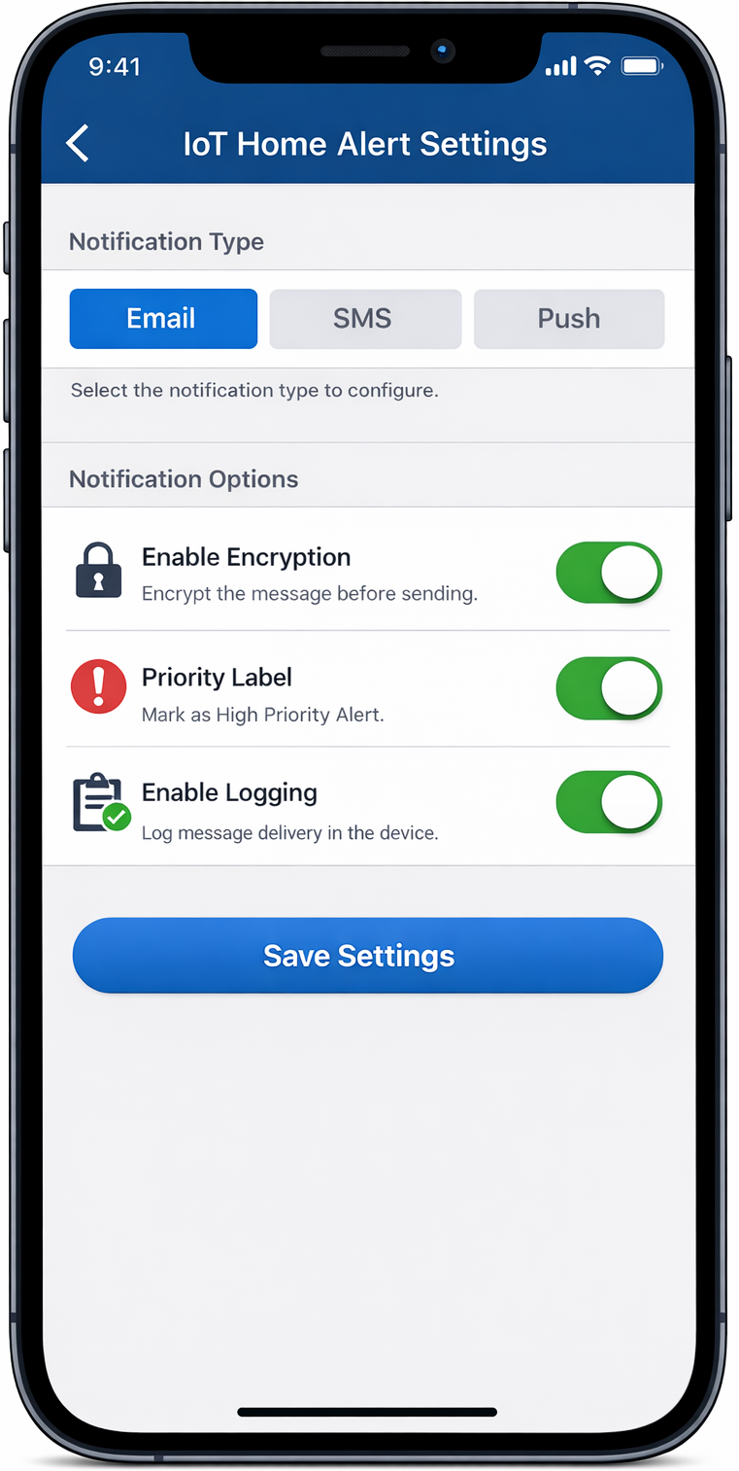

You have installed an IoT security device in your home. Whenever an event occurs the device sends a notification to your smartphone. The system currently supports three basic types of notifications: 1) Email Notification 2) SMS Notification, and 3) Push Notification. Each notification type delivers the same alert message using a different communication channel. The mobile app associated with the IoT device receives and displays these notifications.

The mobile app, as you can see in the figure above, provides users with configurable options to enhance how notifications are handled. The options are listed below:
- Enable Encryption: The message should be encrypted before being sent.
- Priority Label: The message should be tagged as “High Priority” before delivery.
- Logging: The notification delivery should be logged in the IoT device for record-keeping and auditing purposes.

Task: Choose the appropriate design pattern for sending notifications to seamlessly provide the above features to users.

CSE-214 Online - 2 (A2)
Structural Design Pattern
Duration: 25 minutes

ZBazar is a subscription-based grocery delivery service that lets customers set up a recurring monthly bazar bundle that is automatically delivered to their homes. The platform offers preset packages (such as Small, Family, and Mega) and single grocery items (individual items like rice, oil, pulse, etc.). Preset packages consist of multiple single items. Each item has its specific name, price, and weight. Users can create or modify their own Custom Bazar by combining one or more preset packages and/or single items. A custom package may include only individual items, only preset packages, or a mixture of both. Users can also include their previously created custom packages. The system must support calculating the total price and weight of any configuration and displaying the complete structure of the custom package.
Task: Choose the appropriate design pattern to solve this problem and implement a minimal demonstration.

CSE-214 Online - 2 (B1)
Structural Design Pattern
Duration: 25 minutes

Dlachal is an online grocery platform that has grown rapidly. It now needs to keep users informed about key subscription events. Whenever a user's monthly bazar is confirmed, dispatched, or renewed, the system must send out a relevant notification to the concerned user.
However, its user base is diverse. Some users prefer Email, others rely on SMS, and a growing segment expects Push Notifications or WhatsApp messages. Product management has made it clear that new communication channels will be added over time as the platform expands into new markets.On the other side, the notifications themselves are also evolving. The content, tone, and structure of a "payment failed" alert is very different from a "your bazar is on the way" update, and the business team regularly wants to introduce new event types as new features roll out.
The engineering team has been tasked with designing a notification system that is clean, maintainable, and easy to extend, without the codebase turning into an unmanageable mess every time a new channel or a new event type is introduced.
Task: Choose the appropriate design pattern to solve this problem and implement a minimal demonstration.

CSE-214 Online - 2 (B2)
Structural Design Pattern
Duration: 20 minutes
A company is developing a Smart Home Control App that allows users to control various smart devices using voice commands.
The system already supports devices that follow the company’s standard interface:
public interface SmartDevice {
void turnOn();
void turnOff();
}
Currently supported devices include Smart Light, Smart Fan, and Smart AC. All of them correctly implement SmartDevice. The company now wants to integrate third-party smart devices from other manufacturers. However, these devices do not follow the SmartDevice interface.

1. OldSmartBulb
public class OldSmartBulb {
public void powerOn() { }
public void powerOff() { }
}

2. LegacyHeater
public class LegacyHeater {
public void startHeating() { }
public void stopHeating() { }
}
However, these devices need to be integrated without modifying the existing interface. Also, third-party device classes cannot be changed, and the app should continue to work using the existing methods. Also, the system should allow adding more third-party devices easily in the future. Your task is to design a solution that allows all third-party devices to be controlled using the SmartDevice interface without modifying their original implementations.

CSE-214 Online - 2 (C1)
Structural Design Pattern
Duration: 25 minutes
ZBazar traditionally offers three fixed Ramadan packages every year. They are: Standard, Special, and Premium. These packages have predefined contents and pricing, and over time, they have become very popular. Many customers not only purchase them for personal use but also send them as gifts to friends and relatives during Ramadan. The structure and pricing of these Ramadan packages are well-established and are part of ZBazar’s seasonal business model.
However, recently, ZBazar has received requests for slight customization. Some customers want to add fruit, others want to include sweets, and others want to opt for premium gift packaging when sending a package to loved ones. Instead of allowing full customization, ZBazar decided to provide limited flexibility by allowing customers to optionally add: (1) a predefined Fruit Package, (2) a predefined Sweet Package, and (3) premium gift packaging for presentation purposes. These enhancements may be applied in any combination. [The fruit and sweet packages are sold throughout the whole year and are also part of ZBazar’s business model.]
Your task is to make the existing system capable of handling this Ramadan's special flexibility without modifying the existing packages. You can safely assume that the system already supports the previous business model. The system must correctly calculate the final price and description of the customized bundle while preserving the original package structure.

CSE-214 Online - 2 (C2)
Structural Design Pattern
Duration: 25 minutes

ZBazar is an online grocery platform that offers multiple delivery options, as given below:
- Standard Delivery (delivered within 24 hours)
- Express Delivery (delivered within 4 hours)
- Scheduled Delivery (delivered at a chosen time slot)
Each delivery type has its own pricing logic and estimated delivery time calculation. Regardless of the type, every order must ultimately be dispatched using a physical transportation method. Until now, ZBazar has relied on bike couriers and van deliveries to fulfill orders. Recently, however, the company has decided to introduce drone delivery in selected cities to speed up last-mile logistics. As a result, the development team now finds itself updating multiple classes just to support this new transportation method, such as adding drone-specific dispatch logic, tracking integration, safety checks, etc., in several places. The situation is becoming harder to manage because, in the near future, ZBazar is also considering introducing robot delivery for gated communities and smart neighborhoods.
The challenge is that business policies for delivery types may change frequently, while transport technologies may expand over time. However, the current design tightly couples everything and thus forces code duplication and repeated modifications whenever either dimension changes. Your task is to redesign the system with an appropriate design pattern so that new transport technologies like drones or robots to be introduced without rewriting existing delivery-type logic, and vice versa.

Solutions:
A1: Decorator
A2: Composite
B1: Bridge
B2: Adapter
C1: Decorator
C2: Bridge

